NON-SYLLABUS PROJECT REPORT

NMS(NGO MANAGEMENT SYSTEM)

Submitted in partial fulfillment of the degree of Bachelor of Technology

Rajasthan Technical University



By

Sparsh Sharma (PIET18CS138)

Uday Soni (PIET18CS147)

Yash Koolwal (PIET18CS153)

DEPARTMENT OF COMPUTER SCIENCE

POORNIMA INSTITUTE OF ENGINEERING AND TECHNOLOGY, JAIPUR

Table of Contents

* 1. **Introduction**
  2. Aim
  3. DocumentConvention

### Audience and ReadingSuggestion

* 1. Scope
  2. References

**2.0OverallDescription**

* 1. ProductPerspective
  2. ProductFeatures
  3. User class andcharacteristics
     1. User class: Access toVolunteer
     2. User class: Access toDonor
     3. User class: Access toPresident
  4. OperatingEnvironment
  5. Design and ImplementationConstraints.
  6. UserDocumentations
  7. Assumptions

**3.0RequirementSpecifications**

* 1. External InterfaceSpecifications
  2. FunctionalRequirements
     1. Access toVolunteer

**4.0 External InterfaceRequirements**

4.1 User Interface.

* 1. **Introduction**
  2. Aim

This SRS describes all specifications for theNMS developed for the NGO for helping poor school children.

* 1. DocumentConvention

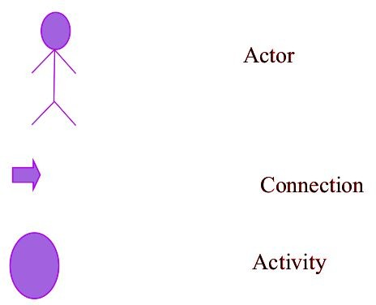

## Audience and reading suggestion

The expected audience consists of the helpersand the manager at NGO and the donors.

**NMS :** NGO Management Website

**Helper :** Helpers/Volunteers at NGO. Poor students and paraphernalia donors approach them.

**Manager :** The person who supervises theworkings and contacts pledged donors.

**Pledged Donor :** The person who has pledged tohelp NGO financially.

## Scope

* The NMS is designed to provide NGO a systemto help poorstudents.
* It allows the helpers to register poor students who approach them for help andmaintain

track record of their performance. Also people can donate paraphernalia for students' help.

* Donors can register and can enter theamount they intend todonate.
* President can supervise things, registerhelpers and can contact pledgeddonors.
* The Websiteis user­friendly and easy touse.

## References

1. [IEEE] the applicable IEEE standardsare publishedin

“IEEE Standards Collection”, 2001 Edition.

1. Classslides.

# OverallDescription

The NMS provides the NGO with a system for its management. The helpers register poor students, update their various info and accept paraphernalia as donations.

The pledged donors can donate by registeringwith the amount of money or they can

The manager checks the records, checks the funds, contacts pledged donors and keeps an account of expenditure.

## ProductPerspective

This websiteis a new, self­contained product which provides the NGO a system for its management.

The NMS is developed as an extension of thework previously done manually and/or on paper.

This website makes the work of both helpersand manager easy.

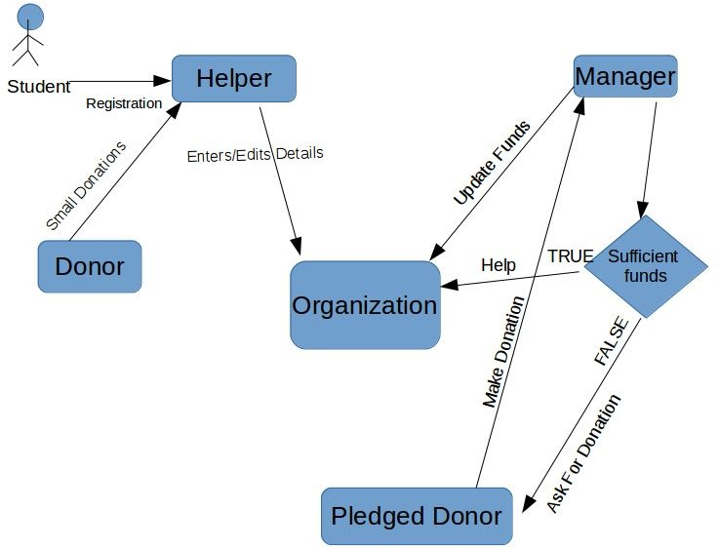

## ProductFeatures

The main aim of this websiteis to providethe NGO a system for its management. Records canbe maintained as a soft copy.

Lesser manual work will be required as this is convenient, efficient and less error prone.

All of the calculations and bookkeeping are done automatically. The interface is obvious enoughto use without any experience.

## User classes andcharacteristics

### HELPERS

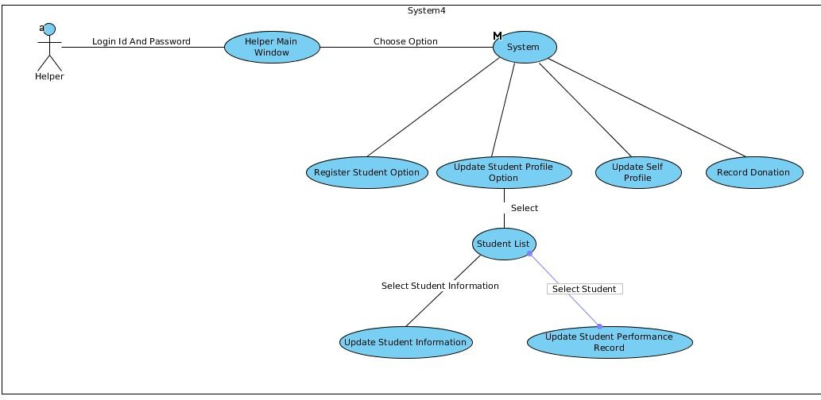

➔ Enter login ID and password provided by manager.

➔ Select what to do : Register student Edit student info

Edit profile (own)

* + 1. PledgedDonor

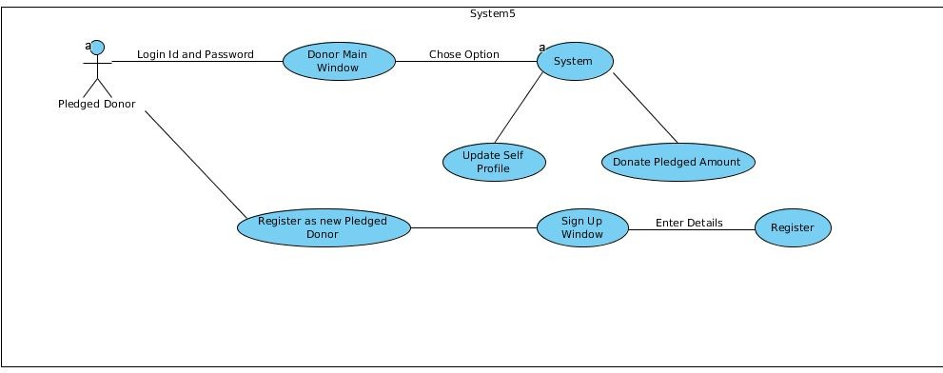

➔ Register (new) / Login(existing). Main window will open.

➔ Donor can pledge money and change frequency of donation.

➔Donor can also edit hisdetails

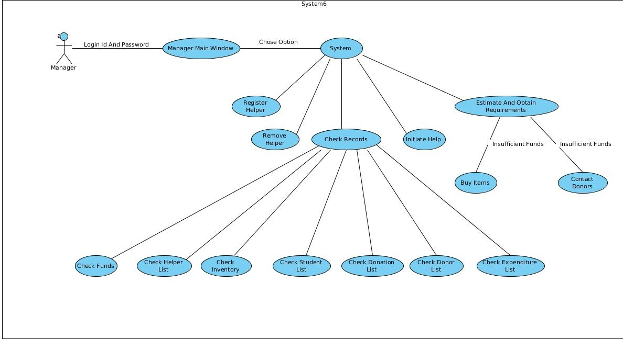**2.3.**2 Manager

➔ Login with id and password provided by our firm.

➔ Manager can access all records which exist(students, donors, helpers)

➔Manager can contact donors forfunds.

➔ Manager can see an account of financial expenses.

➔ Manager can exclusively add/remove helpers.

* 1. **OperatingEnvironment**

NMS will run of both Linux and Windows. Any personal computer with an INTERNET connection will do. Required website includes Java. No special hardware is required.

### Design and ImplementationConstraints

The website runs on Windows and Linuxplatform and is in English.

### UserDocumentation

This is a user friendly website with an easy to understand GUI. It is highly unlikely thatanyone will have a problem usingit.It only involved basic clicking and typing operations. In case of further queries, an e­mail can be sent to the specifiedID.

### Assumptions andDependencies

The website uses a 2­level hierarchy with manager and helpers. Manager can see all the information. Manager receives alerts to verify the payment by donors.

# FunctionalRequirement

## External InterfaceSpecifications

None.

## FunctionalRequirements

### 3.2.1 Access to Helper

|  |  |
| --- | --- |
| User Case Name | Access to Helper |
| Priority | Necessary |
| Trigger | Select appropriate buttons |
| Pre­Condition | Device should support NMS and should have login ID, password. |
| Basic Path | Login screenappears where identity of helper isconfirmed. Helper can register a student by entering hisvarious info.  Helper can update a  student's profile |

|  |  |
| --- | --- |
|  | with his marksor any otherchanged info.  Helper can change his own profile details.  Helper can accept donations of paraphernalia like books, bags, shoes etc. |
| Alternate Path | ­ |
| Post Condition | Helper should be on starting dialog box |
| Exception Path | If entered ID/Password is/are incorrect, access is denied and window does not change. An error is shown in a dialog box when adding details in incorrect format. |

**3.2.1 Access to**Donor

|  |  |  |  |  |  |
| --- | --- | --- | --- | --- | --- |
| User | Case | Name | Access | to | Donor |

|  |  |
| --- | --- |
| Priority | Necessary |
| Trigger | Select appropriate buttons |
| Pre­Condition | Device should support NMS. |
| Basic Path | Login screen appears where donor can register(new) or login if he has an existing account.  Donor can changehis pledged amount and frequency of donations in a year (one ortwo).  Donor can donatehis pledged money if he iscontacted. |
| Alternate Path | ­ |
| Post Condition | Donor should be on starting dialog box |
| Exception Path | If entered ID/Password is/are incorrect, access is denied and window does not change. An error is shown in a dialog box when adding details in incorrect format. |

**3.2.**3 **Access to**Manager

|  |  |
| --- | --- |
| User Case Name | Access toManager |
| Priority | Necessary |
| Trigger | Select appropriate buttons |
| Pre­Condition | Device should support NMS. |
| Basic Path | Login screenappears where manager logins.  Register Helper :A new helper isgiven an id,password.  Remove Helper :An existing helperis removed.  Check Records : Manager can access all lists : inventory, students, helpers, donors, expenses, funds.  Contact donors : Manager can contact donors for financial aid. |
| Alternate Path | ­ |
| Post Condition | Manager should be on starting dialog box |
| Exception Path | If entered ID/Password is/are incorrect, access is denied and window does not change. An error is shown in a |

|  |  |
| --- | --- |
|  | dialog box when adding details in incorrect format. |

## 3.3 Non Functional Requirements

**Hardware:** Personal computer

**Operating System:** Windows or Linux

**Internet Connection:** Any suitable connection. **Code Standard:** Coding is done in Eclipseeditor with WindowManager plugin.

**Performance:** The website should function correctly always.

## External InterfaceRequirements

* 1. **UserInterface**

The website is easy to use, user friendly and self explanatory.